**Experiment 3**

**Aim:** To Study Half Wave Rectifier.

**Tools Used:** Virtual Labs.

**Theory:**

**Rectification:** A rectifier is a device that converts alternating current (AC) to direct current (DC), a process known as rectification. On the positive cycle the diode is forward biased and on the negative cycle the diode is reverse biased. By using a diode, one can convert an AC source into a pulsating DC source. In summary we have ‘rectified’ the AC signal. Rectifiers are essentially of two types:

* Half Wave Rectifier
* Full Wave Rectifier

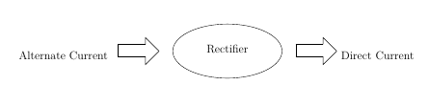

**Half Wave Rectifier:** The simplest kind of rectifier circuit is the half-wave rectifier. The half-wave rectifier is a circuit that allows only part of an input signal to pass. The circuit is simply the combination of a single diode in series with a resistor, where the resistor is acting as a load.

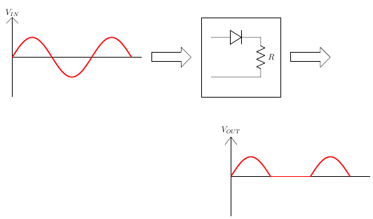

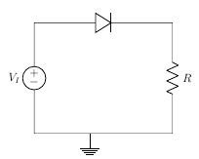

**Half Wave Rectifier Waveforms:** The output DC voltage of a half wave rectifier can be calculated with the following two ideal equations.

$$V_{peak}=V_{rms}×\sqrt{2}$$

$$V_{dc}=\frac{V_{peak}}{π}$$

**Half Wave Rectification for Positive Half Cycle:** Diode is forward biased, acts as a short circuit, passes the waveform through.

For positive half cycle:

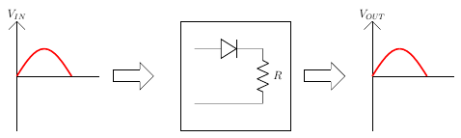

$$V_{I}-V_{b}-I×r_{b}-I×R=0$$

where,

VI is the input voltage,

Vb is barrier potential,

rd is diode resistance,

I is total current,

R is resistance

$$I=\frac{V_{I}-V_{b}}{r_{b}+R}$$

$$V_{O}=I×R$$

$$V_{O}=\frac{V_{I}-V_{b}}{r_{b}+R}×R$$

For rd<< R,

$$V_{O}=V_{I}-V_{b}$$

Vb is 0.3 for Germanium,

Vb is 0.7 for Silicon

For VI<Vb,

The diode will remain OFF. The Output voltage will be,

$$V_{O}=0$$

For VI>Vb,

The diode will be ON. The Output voltage will be,

$$V_{O}=V_{I}-V_{b}$$

**Half Wave Rectification for Negative Half Cycle:**

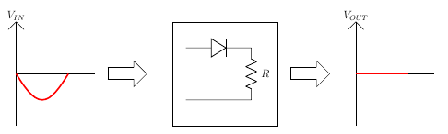

Diode is reverse biased, acts as a open circuit, does not pass the waveform through.

For negative half cycle:

${ V}_{O}=0$ since, $I=0$

**Half Wave Rectification for an Ideal Diode:**

For Ideal Diode,

$$V_{b}=0$$

For positive half cycle,

$$V_{O}=V_{I}$$

For negative half cycle,

$$V_{O}=0$$

**Average Output Voltage:**

$$V_{O}=V_{m}\sin{ωt} for 0≤ωt≤π$$

$$V_{O}=0 for π≤ωt≤2π$$

$$V_{av}=\frac{V_{m}}{π}=0.318V_{m}$$

**RMS Load Voltage:**

$$V_{rms}=I_{rms}×R=\frac{V_{m}}{2}$$

**Average Load Current:**

$$V_{av}=\frac{I_{av}}{R}=\frac{I_{m}}{π×R}=\frac{V_{m}}{π}$$

**RMS load current:**

$$I_{rms}=\frac{I_{m}}{2}$$

**Form Factor:** It is defined as the ratio of rms load voltage and average load voltage.

$$F.F.=\frac{V_{rms}}{V_{av}}$$

$$F.F.=\frac{\frac{V_{m}}{2}}{\frac{V_{m}}{π}}=\frac{π}{2}=1.57$$

$$F.F.≥1$$

$$V_{rms}≥V_{av}$$

**Ripple Factor:**

$$γ=\sqrt{F.F.^{2}-1} ×100\%$$

$$γ=\sqrt{{1.57}^{2}-1}×100\%=1.21\%$$

**Efficiency:** It is defined as ratio of dc power available at the load to the input ac power.

$$η\%=\frac{P_{load}}{P_{in}}×100\%$$

$$η\%=\frac{I_{dc}^{2}×R}{I_{rms}^{2}×R}×100\%$$

$$η\%=\frac{\frac{I_{m}^{2}}{π^{2}}}{\frac{I_{m }^{2}}{4}}×100\%=\frac{4}{π^{2}}×100\%=40.56\%$$

**Peak Inverse Voltage:** For rectifier applications, peak inverse voltage (PIV) or peak reverse voltage (PRV) is the maximum value of reverse voltage which occurs at the peak of the input cycle when the diode is reverse-biased. The portion of the sinusoidal waveform which repeats or duplicates itself is known as the cycle. The part of the cycle above the horizontal axis is called the positive half-cycle, the part of the cycle below the horizontal axis is called the negative half cycle. With reference to the amplitude of the cycle, the peak inverse voltage is specified as the maximum negative value of the sine-wave within a cycle's negative half cycle.

$$PIV=V$$

$$-V_{m }+V=0⟹V=V_{m}$$

$$PIV≥V_{m}$$

**Circuit Diagram:**

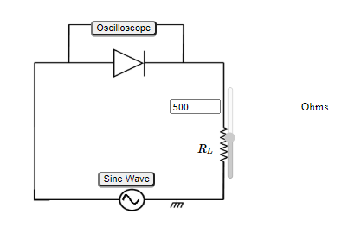

**Wiring Diagram:**

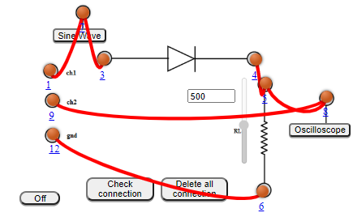

**Experimental Setup:**

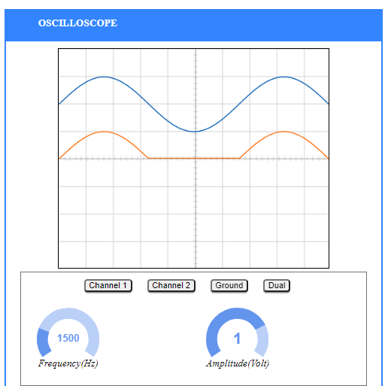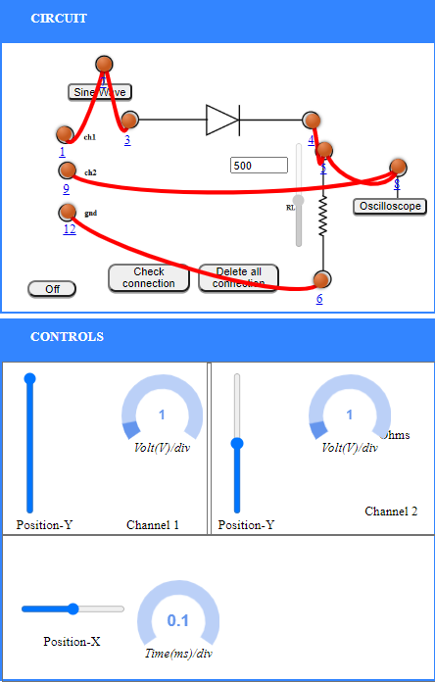

**Graph:**

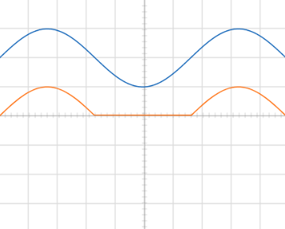

**Observations and Calculations:**

A.C. Frequency = 1500 Hz

Amplitude, Amp= 1Volts

$V_{m}$ = $Amp×\frac{volt}{div}=1×1=1Volts$

$V_{rms}=\frac{V_{m}}{2}=\frac{1}{2}=0.5V$ olts

$V_{dc}= \frac{V_{m}}{π}$ = $\frac{1}{π}$ = 0.31847Volts

Ripple actor , $γ_{exp}$ = $\sqrt{{\left(\frac{V_{rms}}{Vdc}\right)}^{2}-1}$ = $\sqrt{1.57000659}$ = 1.252996672 $≈1.25$

Standard Value of Ripple Factor, $γ_{std}$ = 1.21

%Error = $\frac{γ_{exp}-γ_{std}}{γ_{std}}×100=3.30\%$

­

**Result:** The ripple factor of Half Wave Rectifier is = 1.25 volts.

Standard Value of ripple factor is = 1.21

Percentage error = 3.30%

**Conclusion:** The properties of half wave rectifier has been studied successfully and the ripple factor has been calculated successfully.